深 圳 大 学 实 验 报 告

课程名称： 数据库系统

实验项目名称： 移动设备交互应用

学院： Computer Science and Software Engineering

专业： 软件工程

指导教师： Basker George

报告人 :___杨皓翔___学号： 2023150139 班级： 02

实验时间： 3rd December to 31 December 2025

实验报告提交时间： 2025年12月29日

教务部制
实验目的与要求：(Purpose of Experiment and Requirements)
一、实验目的：
- 了解DBMS系统的功能、Web based数据库的软件组成及工具；
2、掌握数据库软件的使用方法、
3、掌握前台页面，后台数据库的基于WEB的数据库操作方法。

二、实验要求：
1、安装相关软件并浏览软件自带的帮助文件和功能菜单，
2、掌握PHP构建网页以及连接数据库的方法。
3、掌握phpmyadmin创建数据库与数据表的方法；
4、了解mysql的命令以及与php衔接的语句
5、了解网页构造的原理

三、实验设备：
计算机、数据库管理系统如DB2，mysql 等软件。

四、实验内容

1）按照实验指导讲义完成要求的练习题目。
2）附上相关问题的解决方案，以及展示页面

五.问题分析（碰到什么问题，如何解决）

六.实验心得

七.诚信承诺
本组成员郑重承诺在项目实施的过程中不发生任何不诚信现象，一切不诚信所导致的后果均由本组成员承担。

Modify the PHP code to include the following:
1) Proper Layout
2) Header and Footer
3) CSS3 Style sheet
4) Login Page so that, only if the username and password is correct they can ADD DELETE SEARCH and UPDATE Employee Table
Also add button to move record to go to FIRST, NEXT , PREVIOUS, LAST record.
5) IF USER IS NOT LOGGED IN, DON’T ALLOW TO ACCESS ANY OTHER WEBPAGE ON THIS SITE
6) Create User Registration

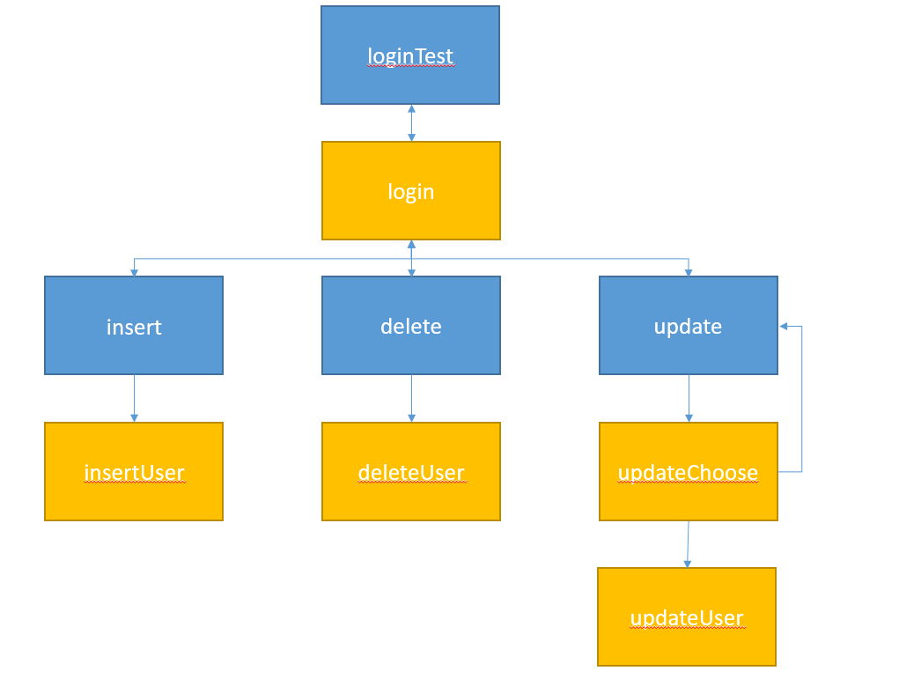
- prepare
Use the SQL below to create a database and one table:
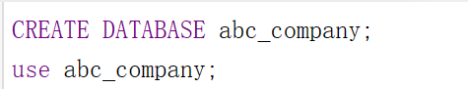
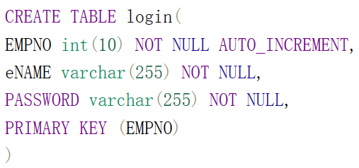
Now we have :
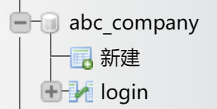
Then use the SQL below to insert data into “login” table:
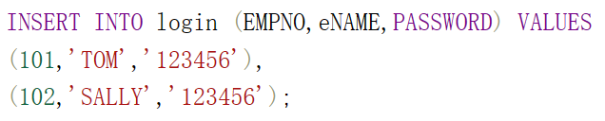
Then use the SQL below to create a table named “emp”:
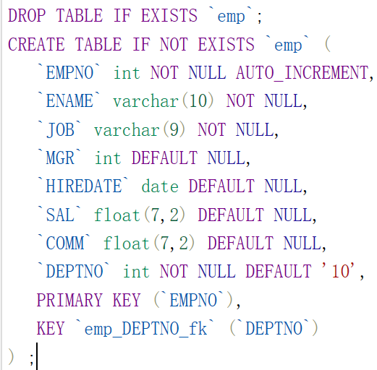
Use the SQL below to insert data into the “emp” table:
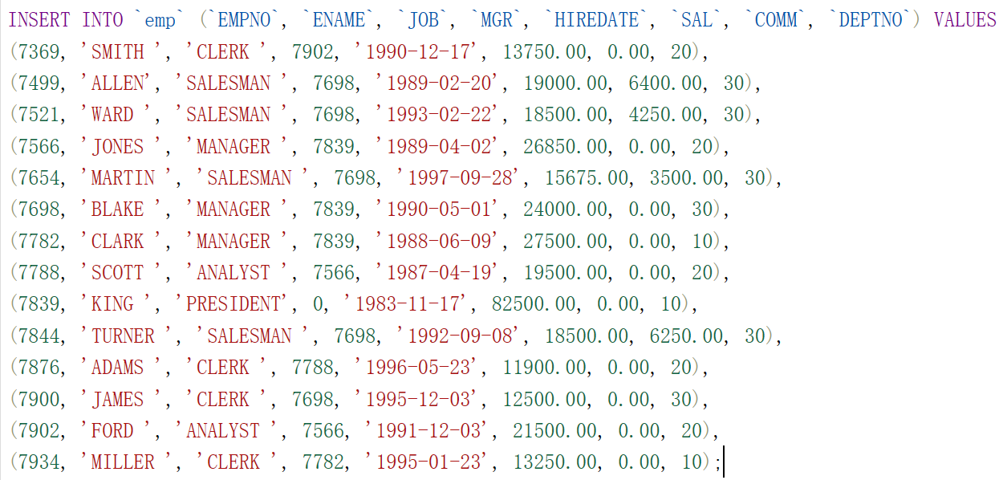
Now,
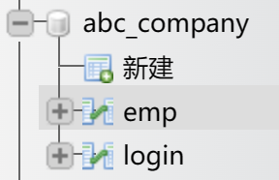
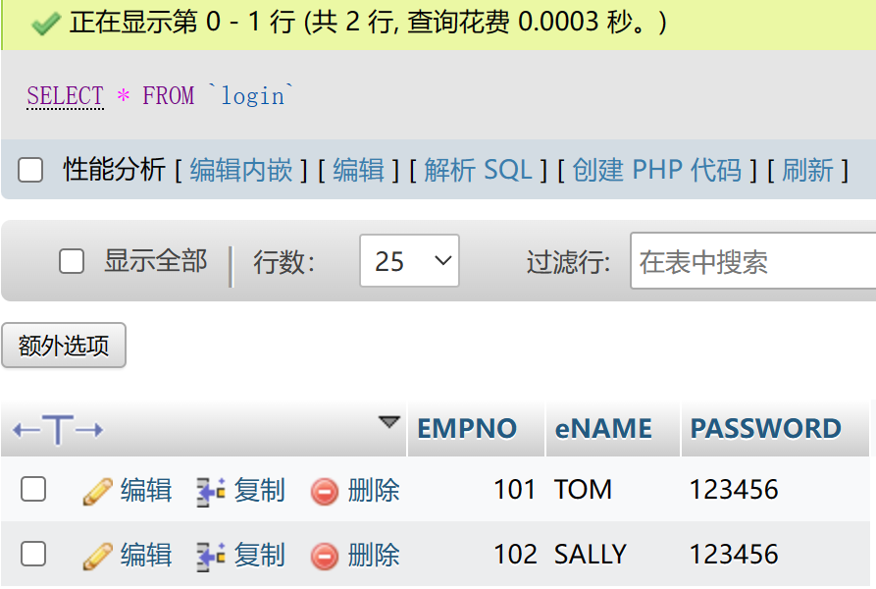
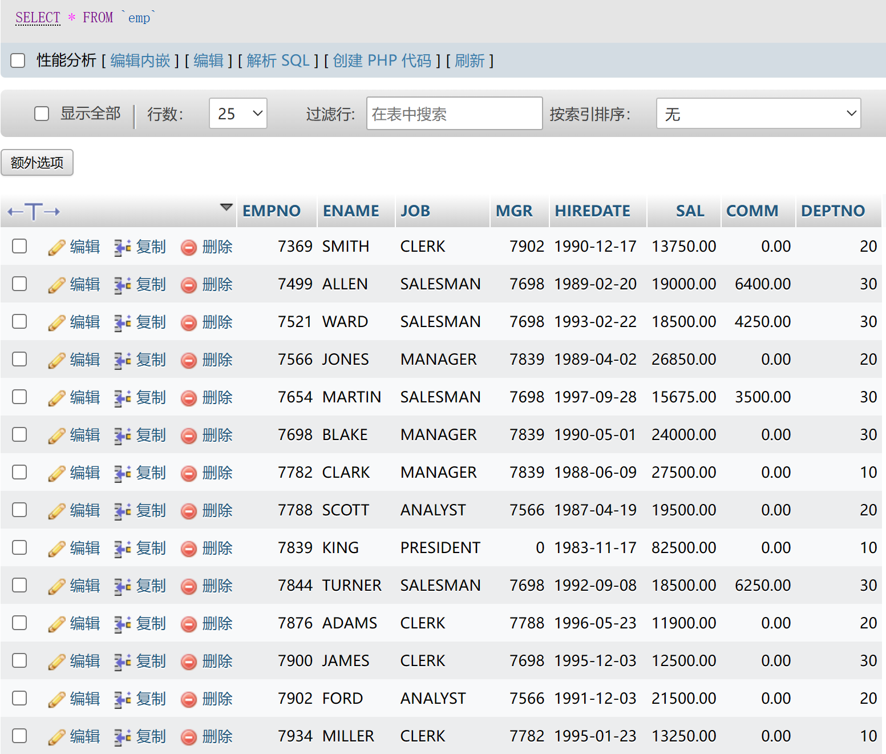
- login pages:
At first my database has two records of login_user:
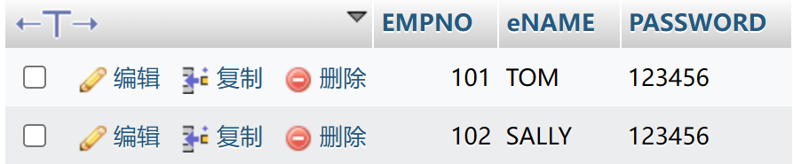

This is the login page, only if your ename, empno and password are all correct, you can login succeed.
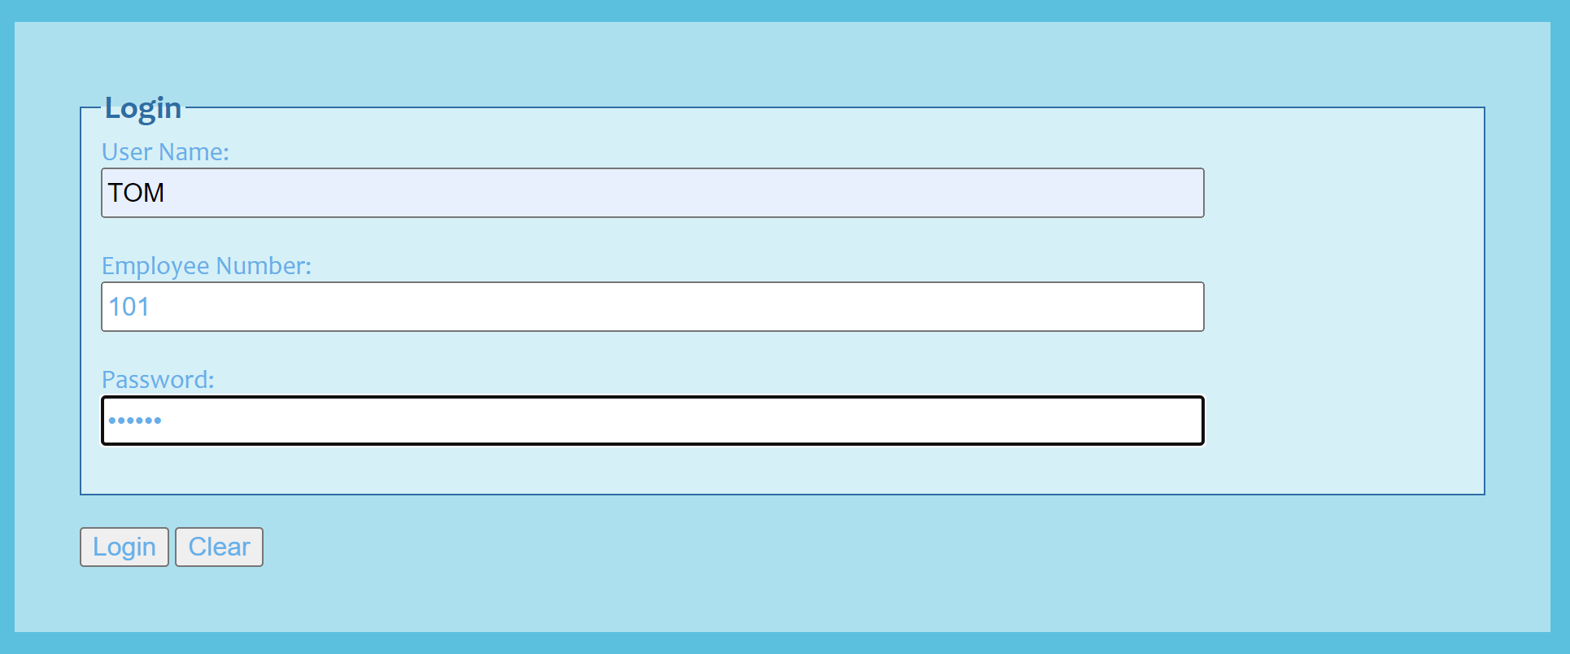
And you will see the last row of the ‘emp’ table, and then you can do next operations.
There are four buttons: insert button, update button, delete button and log out button.
Apparently, log out button will go back to the login page.
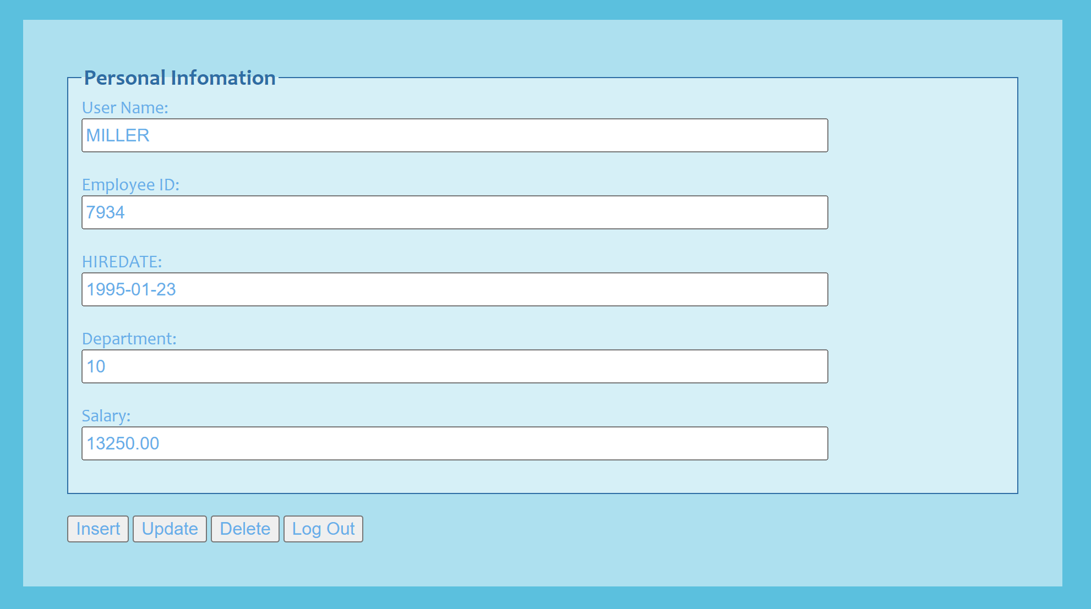

If there is no record in database or the user’s ename, empno and password are not correct , then login failed.
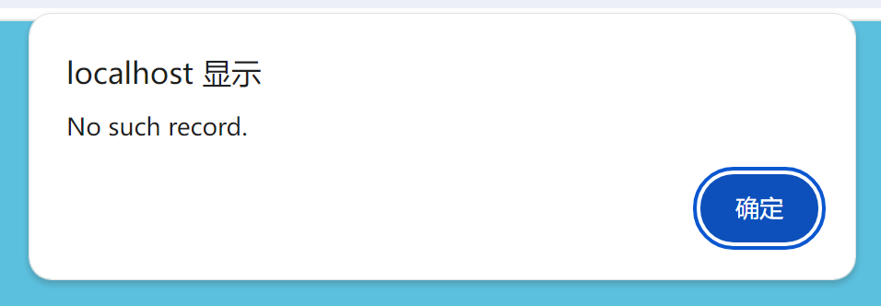

php code:
Connect to the database:

Get the login information:
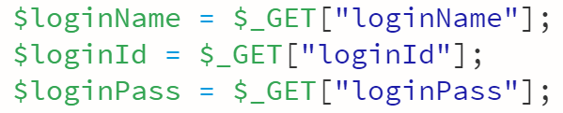

SQL command:

Check if the login is successful:
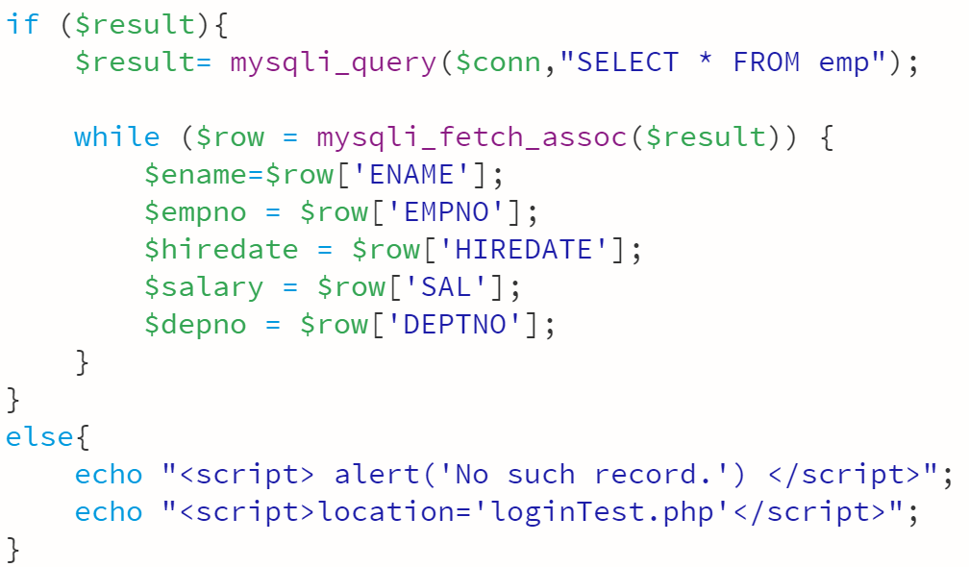
If no record, return to login page, otherwise show information.

- insert page
This is the insert page, enter information and submit. Also, you can return to personal infomation page.

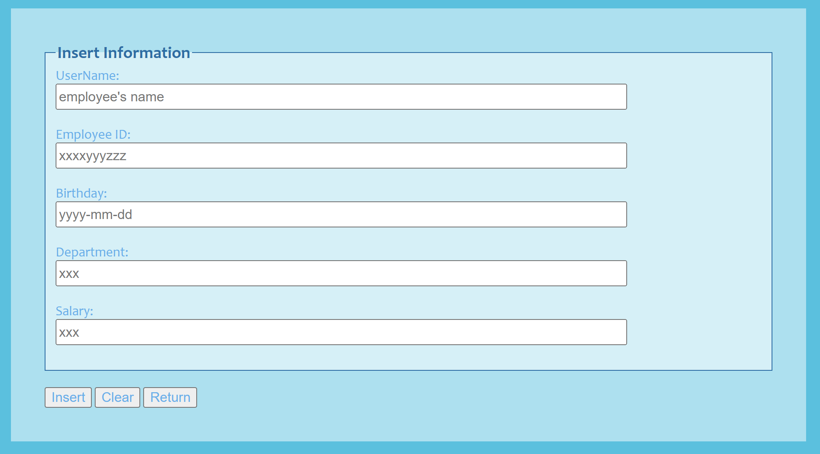

If insert succeed, data will insert into database, and back to personal information page.
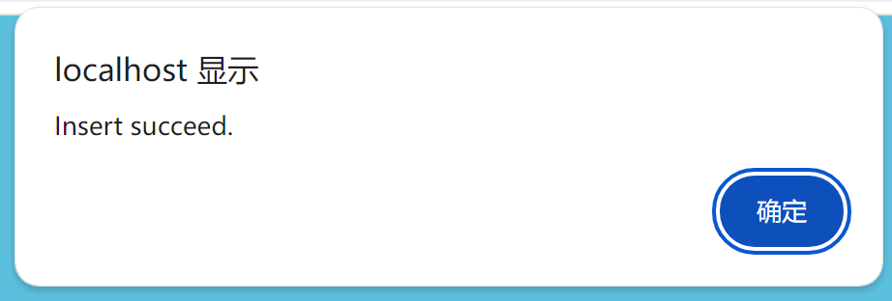
Then you can see the inserted data in your database:
If insert failed, data will not insert into database, then the web page will alert you and back to personal information page.
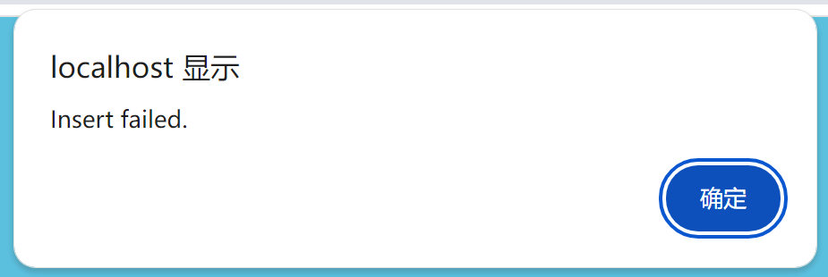

php code:
Connect to the database:
Receive information from insert form:
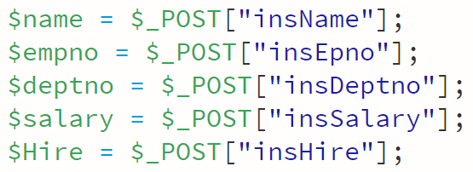

SQL command:

Check if the SQL is successfully executed:
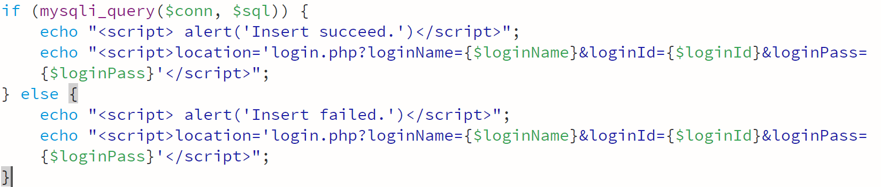

After inserting, no matter what results turn back to personal information page.

- Delete page
This is the delete page, enter delete user and submit. Also, you can clear all the information or turn back to personal information page.
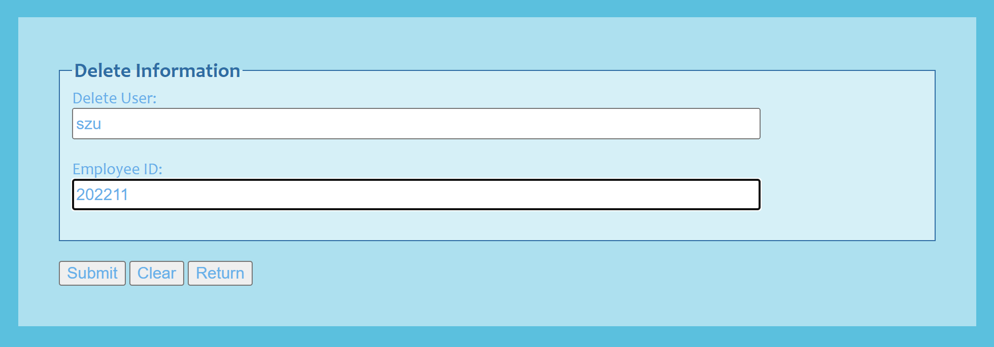

If delete succeed, data will be deleted from database, then the web page will alert your success and back to personal information page.
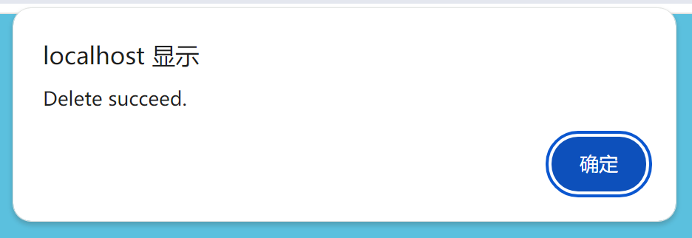
Else, data will not be deleted from database, then the web page will alert your failure and back to personal information page.

php code:
Connect to the database:

Receive information from delete form:
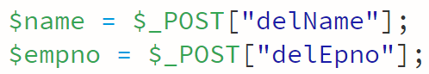
SQL command:

Check if the SQL is successfully executed:
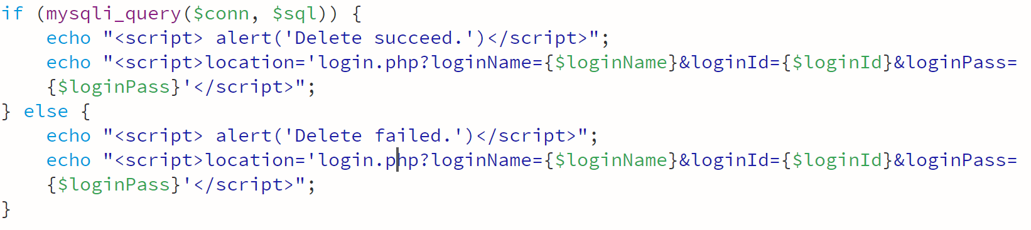
After deleting, turn back to personal information page.

- update pages:
This is the update choose page, choose who you want to update in the database and submit. Also, you can get informed and turn back to personal information page.
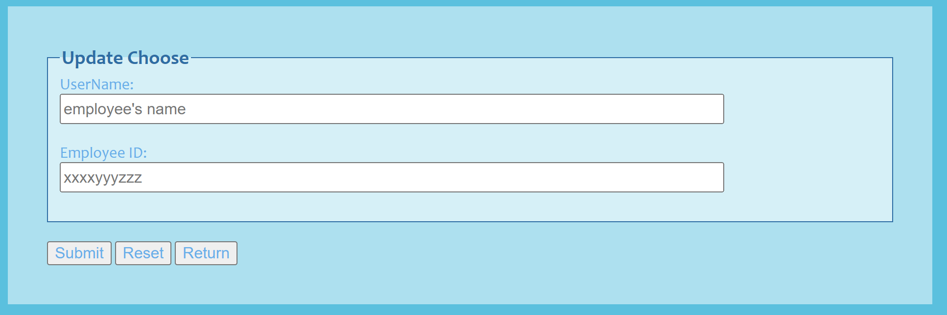

If update choose does not succeed, you will be alerted and back to the update choose page.
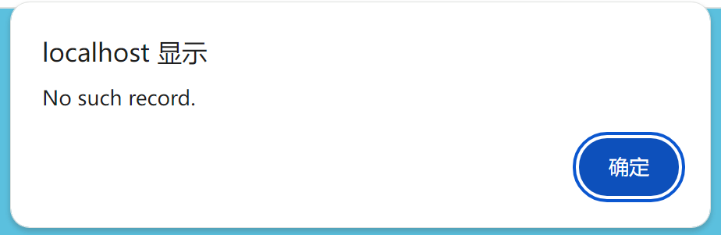
Else, you will enter the update page.
This is the update page, showing you employee’s information. Modify information and submit. Also you can turn back to update choose page to choose another employee.
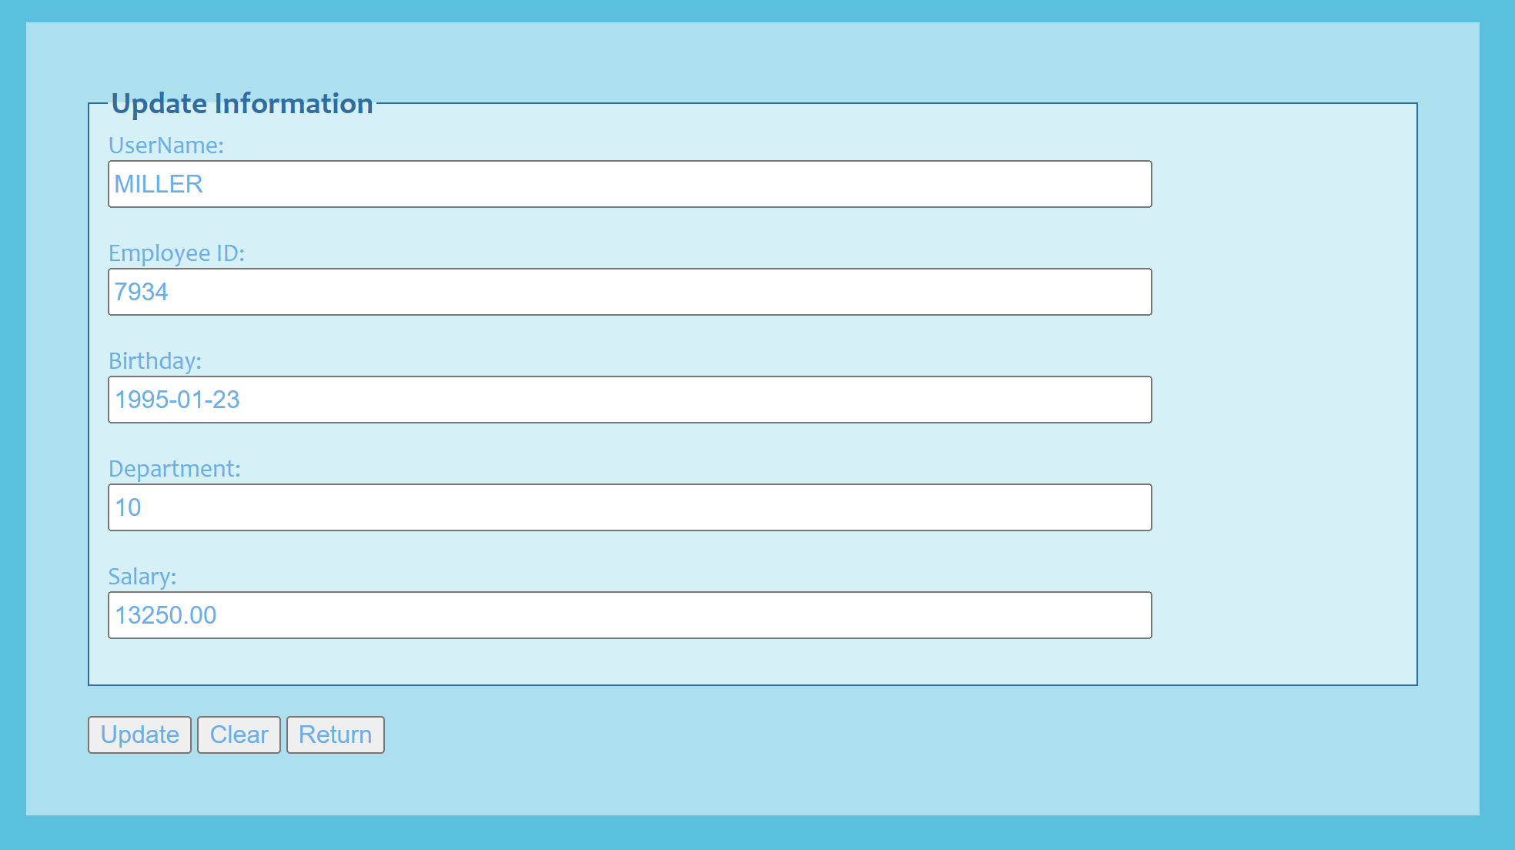

If update succeed, data will be updated in database, and then you will be informed of your success and the web page will back to personal information page.
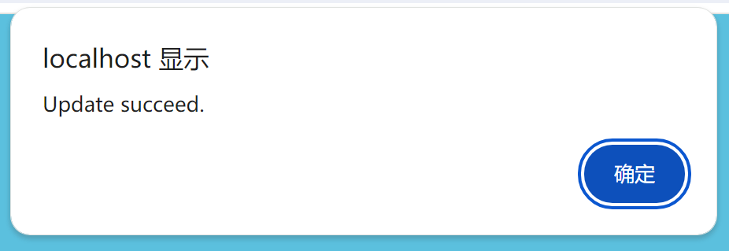

①php code of update page:
Connect to the database:
Receive update employee from update choose page:
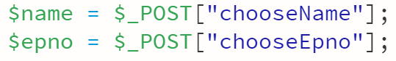
SQL command and check if it is successful:
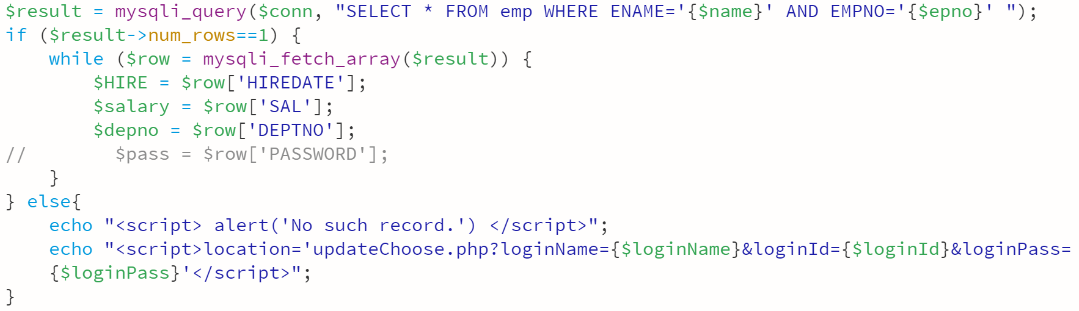
If no record, return to update choose page, otherwise show employee’s information.
②php code of updateUser:
Connect to the database:

Receive update information from update page:
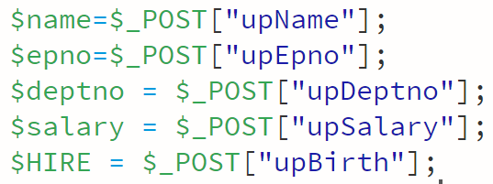

SQL command:

Check if is successful or not:
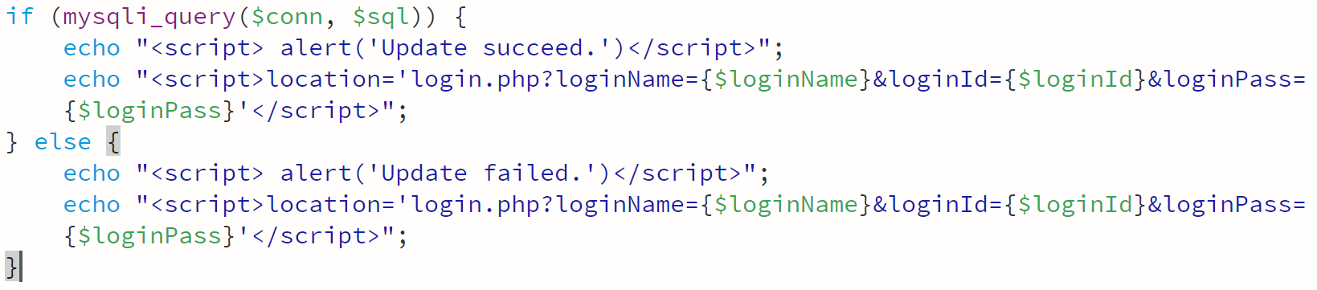
After updating, turn back to personal information page.

- addition
Save login information when jump between pages:
When you jump to another page, send the login information:
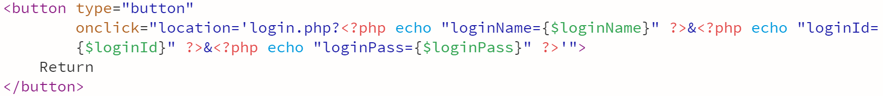

In another page, receive the login information.
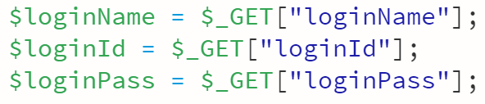

Other pages are just the same.
数据处理分析：(Experiment process and content)
1. Database Design and Data Initialization
At the beginning of the experiment, a database was created using the MySQL database management system. Two tables, namely login and emp, were designed and created using SQL statements.

The login table is used to store user authentication information, including username, employee number, and password.
The emp table is used to store employee information such as employee number, name, job title, and salary.
After the table structures were created, initial test data were inserted into both tables using INSERT statements to support subsequent login verification and data operations.

2. User Login and Access Control Processing
The system adopts a login verification mechanism as the entry point for all data operations. On the login page, users are required to input their username, employee number, and password. The PHP backend receives the submitted data and executes an SQL query on the login table to verify the user’s identity.

If a matching record is found, the login is considered successful and the system redirects the user to the employee information page.
If no matching record is found, the login fails and the user is redirected back to the login page with an error message.
Login information is passed between pages to maintain user identity during the session. Any user who is not logged in is not allowed to access other functional pages, ensuring system security.

3. Employee Data Query and Record Navigation
After a successful login, the system displays the last record in the emp table by default. The application provides FIRST, NEXT, PREVIOUS, and LAST buttons to allow users to browse employee records sequentially. Each button triggers a corresponding SQL query to retrieve and display the correct record from the database.

4. Data Insertion Processing (Insert)
On the insert page, users enter new employee information through a form. The PHP backend receives the submitted data and constructs an INSERT SQL statement.

If the SQL execution is successful, the new data are stored in the emp table and the system returns to the employee information page.
If the insertion fails, an alert message is displayed and the user is redirected back to the previous page.
This process demonstrates effective interaction between front-end forms and the backend database.

5. Data Deletion Processing (Delete)
For the delete operation, users input the employee number of the record to be removed. The backend generates a DELETE SQL statement based on the input.

If the specified record exists and the deletion is successful, the system displays a success message and returns to the employee information page.
If the deletion fails or the record does not exist, a failure message is displayed.
This step verifies the correctness and reliability of the delete operation.

6. Data Update Processing (Update)
The update operation is implemented using a two-step process. First, the user enters the employee number on the update selection page. The system queries the emp table:

If no matching record is found, an error message is displayed and the user is redirected back.
If a matching record exists, the system navigates to the update page and displays the employee’s current information.
On the update page, the user modifies the employee data and submits the form. The backend then executes an UPDATE SQL statement. If the update is successful, a confirmation message is shown and the system returns to the employee information page.

7. Page Navigation and Data Persistence
During page navigation, login information is passed as parameters to ensure user identity remains consistent across pages. Each functional page checks the login status before execution, preventing unauthorized access.

深圳大学学生实验报告用纸

指导教师批阅意见：

成绩评定：


指导教师签字：
Basker George
2026年 01月 2日

备注：
注：1、报告内的项目或内容设置，可根据实际情况加以调整和补充。
2、教师批改学生实验报告时间应在学生提交实验报告时间后10日内。

